LOW CARBOHYDRATE
Healthy Eating Advice
May 2023

Background
To explain how a low carbohydrate diet can have a positive effect on reducing your weight, we first need to look briefly at our natural physiology.

How our body deals with sugar and starch
When we consume sugar, our bodies respond by producing the hormone insulin. Insulin then pushes the sugar into the cells of our muscles to be used for energy. When we eat more sugar than we need, the body processes this, either storing it as belly fat or by putting it into our liver. Therefore, we become overweight and may also develop a ‘fatty liver’.
Every time we eat, more insulin is produced to help our bodies manage the food and so it doesn’t get a break if we are constantly snacking. It is therefore advisable to only eat when you are hungry which maybe between 1 and 3 meals a day. Between meals, when insulin levels are low, your body uses fat for energy instead.
It is also thought that a low sugar diet can have a positive effect on your blood pressure, as indeed losing weight overall will. This is because the hormone insulin also helps us to retain sodium via the kidneys. Sodium has the effect of raising our blood pressure, which for most of us is not a good thing. When we reduce the sugar in our diet, we need less insulin. This means that less sodium is retained by our kidneys and our blood pressure will reduce naturally.
Why are we talking about sugar when I have been advised to reduce my carbohydrate intake?
What many people don’t know is that carbohydrates are broken down in the body into different forms of sugar. Starchy carbohydrates such as bread, rice, pasta or potatoes, convert into a surprising amount of sugar. For example one slice of brown bread breaks down into the equivalent of 3 teaspoons of sugar. One banana is the equivalent to eating 6 teaspoons of sugar. Whilst a large serving of white rice (90g) can convert into the equivalent of 20 teaspoons of sugar!
Vegetables can also be divided into starchy vegetable and non-starchy vegetables. For simplicity, we can divide them between those grown below ground and those above ground. Starchy vegetables include most vegetables that are grown underground, such as potatoes, carrots and parsnips. Non-starchy vegetables are the majority of those grown above ground and can be eaten generously, such as leafy greens and salad vegetables. In a nutshell, if you eat fewer carbohydrates and reduce your sugar intake your body will become better at burning fat and you will lose weight and reduce the amount of insulin needed by your body. If you are still finding it difficult to lose weight despite eating a low carbohydrate, low sugar diet, you are probably eating too much fat, so your body is using this instead of your stored fat. If you reduce your fat intake a little then hopefully you will start to see results.
How many carbohydrates am I allowed to eat on a low carbohydrate diet?
Low carbohydrate means consuming less than 130g of carbohydrates a day. Some people may even choose to eat less, you may have read about the “Keto diet” which advocates only 25g a day! It is what works for you and your personal preferences.
Equally, some people find it easier to think in ‘teaspoons of sugar’. One teaspoon (or sugar cube) is equivalent to 4g of sugar.
Will I get any side effects on switching to a low carb/healthy fat diet?
When you consume carbohydrates, your body releases sugar that results in you feeling a ‘sugar high’. When the excess sugar is then stored as fat, your blood sugar drops which leads to a ‘sugar dip’. This then creates your drive for wanting more sugar and so the cycle continues. Eating a lot of carbohydrates can leave you feeling fatigued and lethargic and constantly hungry.
When you switch to a low carb diet, most of your energy will be provided by your fat instead. In the first few days you may experience sugar cravings, but your body will adapt to this and the cravings will subside. This should result in you feeling more energized. It should also help you lose weight.
Some people may also feel a little lightheaded to begin with. The reason for this is due to reduced retention of some sodium and water into the cells. As you read above, insulin drives sodium into your cells. If you have less insulin due to consuming less carbs, this effect is reduced. You may find that you are going to pass urine more frequently to begin with as your body works to get rid of the excess sodium and water. Your blood pressure can also then drop as a result which makes you feel lightheaded.
Generally, the drop in your blood pressure is a good thing for you. Please make sure you drink adequate amounts of water which may help. This is very important, and we recommend between 2 and 3 Litres of water per day, sipped slowly throughout the day rather than in large quantities. If you have high blood pressure, then we would hope to see that it will reduce to healthier levels.
Some people may also experience a change in their bowel habit which is thought to be the gut having to adapt to the new diet. The most common complaint is of constipation though some people do report loose stools. Again, make sure you drink adequate amounts of water and some people also find increasing fibre by consuming more vegetables may help. If you change in bowel habit lasts longer than 3 weeks, this may not be due to your change in diet so please consult your Doctor.
NB: If you are on blood pressure tablets, please consult your Doctor before converting to a Low Carb Healthy Fat diet so that you can be provided with the correct advice and support.
Where can I get more information?
Please note we are in no way affiliated to any of these websites, reading list or podcasts, the list is certainly not exhaustive it is provided for information only and content has not been verified by your clinician

Websites - Scan with your Phone

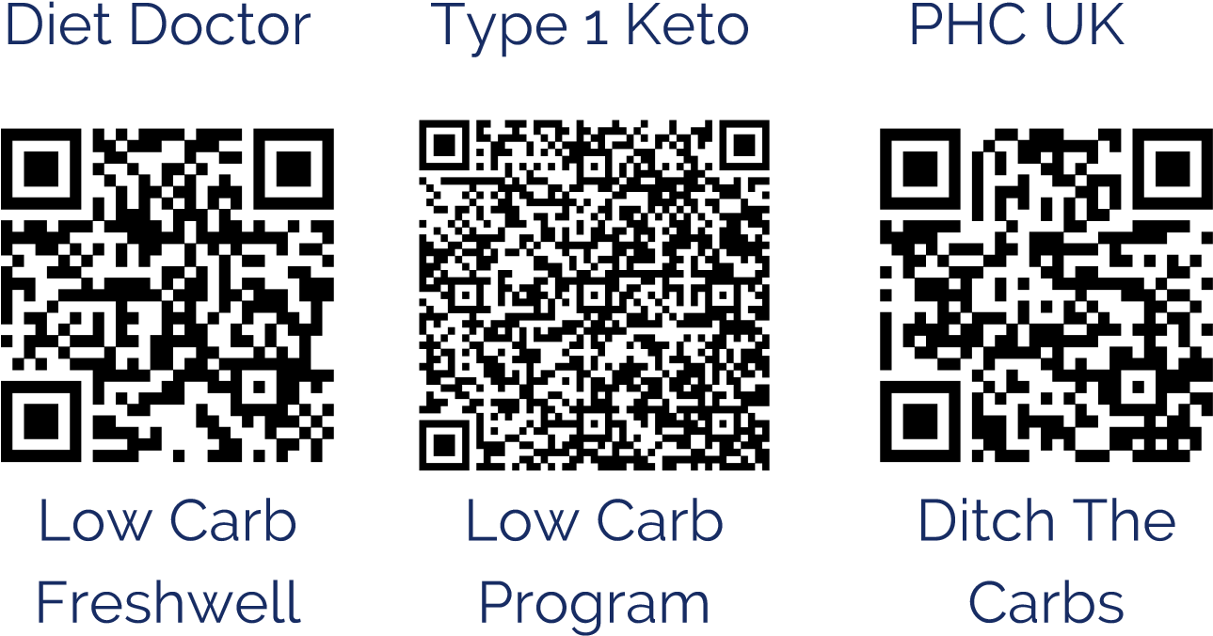
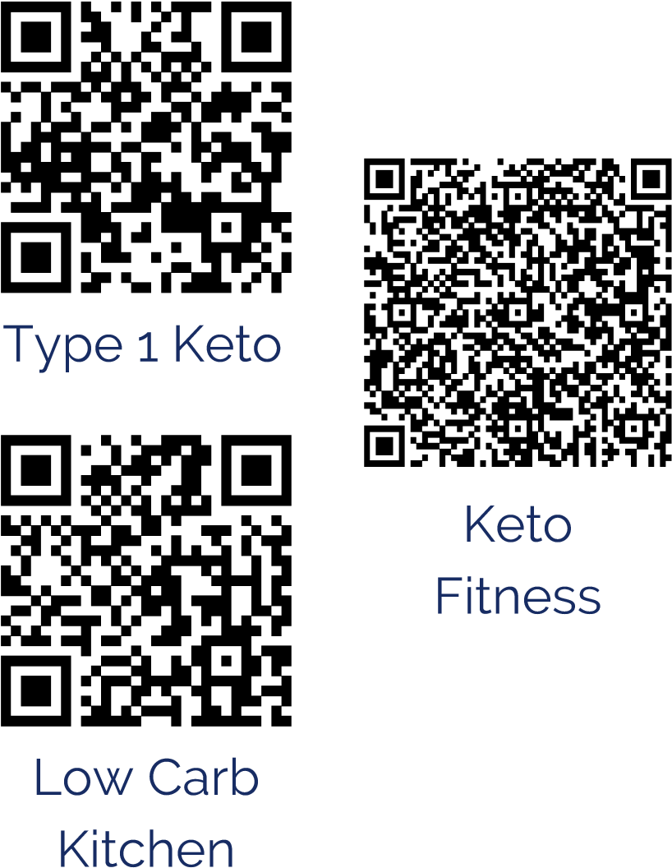

Prediabetes Guide | Metabolic Health Guide | Diabetes Community

Books
·Stay off my operating table by Dr Philip Ovadia
·Wheat Belly by Davis, William
·Eat Rich, Live Long by Cummings, Ivor & Gerber, J
·The P:E Diet by Naiman, Ted
·The Big Fat Surprise by Teicholz, Nina
·Why we get sick by Bikman, Benjamin
·Metabolic by Lustig, Robert
·Why do we get fat and what to do about it by Taubes, Gary
·Fat Chance: The hidden truth about sugar, obesity and disease by Dr Robert Lustig
·Eat fat: A step by step guide to low carb living by Deakin. T
·The Diabetes code: Prevent and reverse type 2 diabetes naturally by Fung, Jason
·The Obesity code by Fung, Jason
·The Glucose revolution – Jessie Inchauspe
·The stress solution: 4 steps to a calmer, healthier and happy you by Dr Chatterjee.
·Fork in the Road: A hopeful guide to food freedom by Unwin, Jen
·The Case Against Sugar by Taubes, Gary
·The 8-week blood sugar diet: Lose weight and reprogramme your body by DR Michael Mosley

Podcasts Apps
- UKlowcarbpodcast,
- Stay off my operating table, Freshwell App
- A Thorough Examination via BBC
- lowcarbMD Google Play Store

