‘What Next?’
The Results

1. Please tick one box to indicate what area you would like the practice to look at next?

 | Number of Patient s
Opening Times | 2
Appointment System | 10
On-Line booking of appointments | 13
Getting test results on the phone | 3
General review, premises, staff parking etc. | 7

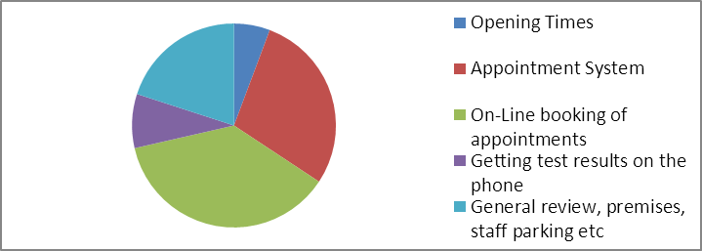

2. In your opinion how often would you say you visit the surgery?

Number
of
patients
Regularly | 14
Occasionally | 19
Rarely | 2



% under 16 | 0%
% 17 – 24 | 0%
% 25 – 34 | 11%
% 35 - 44 | 11%
% 45 – 54 | 14%
% 55 – 64 | 30%
% 65 – 74 | 14%
% 75 – 84 | 14%
% over 85 | 6%

Your Details
Male | 31%
Female | 69%

White British | 94%
White Irish | 3%
Polish | 3%

Other Suggestions and Comments from Question 1
Ringing for results and being able to speak to a Dr. even if there negative sometimes you may still have the problem, and with a little bit of advice could maybe resolve the situation/problem. Unfortuately Dr. Baber is on long term sick is it possible to have Dr. Malone added to the online booking system.

In the past, we only had to wait a few days to see our own GP. It seems now that there is often a wait of 2 weeks. Perhaps availability of individual GPs is something that could be considered at some point.

automated booking system - could there be a seperate number for Dr Milln, as it is just press number 1 for either doctor

I do no think you can improve any of this

It would be much easier to book an appointment online. it would save time and money to everyone. it works really well in basingstoke where i used to use it when i lived there.

I feel that there should be a system for appointments. At the moment sometimes if you ring up and ask for an urgent appointment you are offered it, at other times you go through triage.

I am well satisfied with everything

I have never had a problem being seen by a doctor and appreciate the surgery more than they will ever know. I hear shocking stories from my colleagues who have serious problems gaining appoitments or even talking to a triage nurse at the surgery. You are an excellent surgery and that includes ALL members of staff who work there. Keep up the good work and well done on your excellent service

Privacy at Reception still not good. People who need to go to Reception direct from seeing a doctor or nurse tend to hang about at the desk until they are dealt with.

Yes, further to my previous email on the subject - if your first appointment is 08:30 then you cannot open surgery at 08:25. People are turning up from 08:15 and should be able to come inside and sit down. If you do not want to open doors of surgery until 08:25 then first appointment should be 08:40

Why one has to wait so long for an appointment, if relatively urgent.

