Dear Patient

Thank you very much for your continued support and participation in assisting us with our virtual Patient Participation Group. The Information you provide us with is much appreciated and all the data is considered when discussing any possible changes within the practice.

May I also take this opportunity to welcome any new members to the group.

The “On-Line services” questionnaire is now closed and the results are attached to this
e-mail/letter. The Results are also published on the surgery website for all to see.

We would welcome any feedback you may have on these results.

It is very pleasing to see that our members have increased from 53 to 59 in the last year, and that there have been 43 responses to this survey.

It is a little disappointing to see that 61% of patients did not realise they could order prescriptions via the website but great to see that once they had looked at the website 81% found it very or fairly useful.

After looking at the results and discussing them at a Practice meeting, the practice would like to put the following into action

- Set up On-Line appointments so routine appointments can be booked with a specific GP up to 4 weeks in advance.
    - The Triage system via the phone will continue to run as normal for urgent appointments.
    - The automated booking system via the phone will continue as it does now so patients who have no access to the internet can still make their own appointments.
- Better advertising of our Website and the services it offers.
- Keep the Website regularly updated

Can we also thank you for all the positive comments made on the survey.

We hope you will be happy with this outcome but would encourage you to give feedback about this decision either by letter, email or telephone.

Can we thank you once again for your continued support.
Many thanks again for all your help
Your Practice Team

Results of PRG
On-Line Services
Dec 2012 – Jan 2013

- When do you have access to a computer connected to the internet?
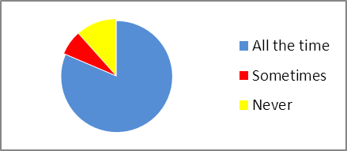
All the time | 35
Sometimes | 3
Never | 5

- Are you aware you can order prescriptions on-line?
- How useful do you find our Website (www.oldfirestationsurgery.co.uk)?
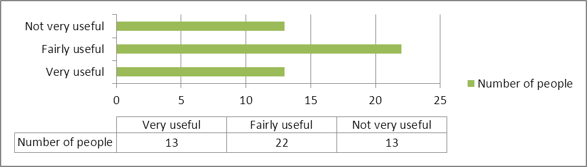

- Would you like to be able to book, cancel and rearrange GP appointments on-line?


- How far into the future would you like to be able to book appointments on-line?
The next day | 10
In the next 3 days | 12
1 week in advance | 9
2 weeks in advance | 7
4 weeks in advance | 11
6 weeks in advance | 6
All comments to this question have been read and are greatly informative and appreciated.

- Are there any comments you would like to make about our website and services it offers?

All these comments have been read and are very much appreciated. They will all be taken into consideration when these results are discussed.

43 out of 59 members of the participation group completed the survey

Out of that 43
SEX
Male | Female
28% | 72%

AGE
under 16 | 0%
17 – 24 | 0%
25 – 34 | 9%
35 - 44 | 19%
45 – 54 | 19%
55 – 64 | 21%
65 – 74 | 16%
75 – 84 | 14%
over 85 | 2%
ETHNIC BACKGROUND
White British | 98%
Welsh | 2%

